1. BS Type Communication: BS Protocol is to connect the Time Attendance terminal to the Server through WAN network, to get the time attendance data and manage the employee data. It use the WebSocket protocol which is based on TCP/IP, it’s default with [encryption](https://cn.bing.com/dict/search?q=encryption&FORM=BDVSP6&mkt=zh-cn), but it could also use the WebSocket communication without encryption. Main logic is Server monitoring (Listening) a specific Port, Time Attendance Device MENU has to set the Cloud Server Address and Port, and Device connect to the Server, then it can communicate successfully.

websocket: API in XML format

Time Attendance Device

Server

It has another interface document to introduce the XML API.

2. in order to allow the client to test the API interface directly, we offer a local DEMO for testing. The Demo program runs in the local PC, and build a local WebSocket Server, and then set the Server Address and Port on the Time Attendance Device, then we can test the device locally. After you get some knowledge about the interface, you can use your own development language to develop your own Cloud Software, interface combination (there’s introduction for some common interface combination in another document. ), to achieve your service logic.

3. DEMO use:

For the DEMO, it has source code and the EXE program, the Source code is based on C#, the

Demo program is as following:

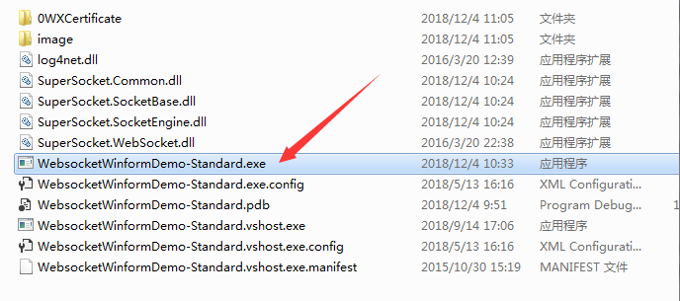

Double click to run the EXE program.:

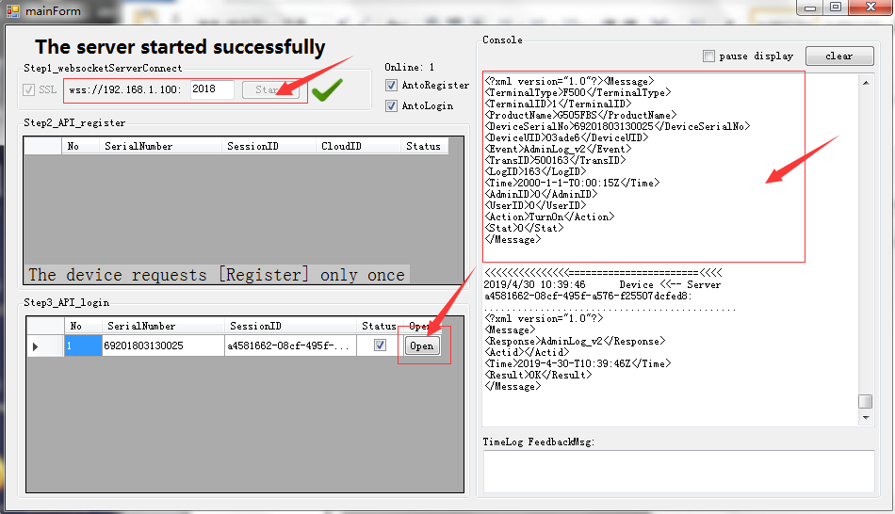

1.  this shows the IP and Port of the Computer, this means we have to set this IP address and Port to the Time Attendance Device MENU as the Server Address & Port.

(NOTE: Sometimes, the program shows a different IP as your computer IP, we have to use your Computer True IP as the Time Attendance Device Server Address)

NOTE: wss:// is the WebSocket communication with SSL encryption, if enable SSL from demo (means tick SSL), from the Time Attendance Device MENU, when we input the Server Address, we have to start with wss:// . if we didn't enable the SSL from DEMO (didn't tick the SSL), from the Time Attendance Device MENU, when we input the Server Address, we have to start with ws:// .

For Example, the PC IP is 192.168.1.100, the Demo will get this IP address automatically, but if your computer has multi network cards, it might shows a wrong IP address from DEMO program, and the Time Attendance Device Server Address should use the actual IP address of the computer. Port : have to above 1000, and use a port that doesn't occupy the System port.

2. 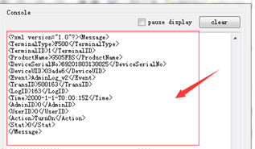

This is the xml original data from the communication, we can see the communication data details.

NOTE: if cannot see any connection of the device, we have to check if the Time Attendance Device Server Address is set as the current PC IP address(from which Computer we are running the DEMO program on), check the format is correct or not. And then run CMD on your local Computer to ping the Time Attendance Device IP address, if can ping failed, please check the network. If the Time Attendance Device and the DEMO shows the IP in different segment, please input the Computer’s actual IP address. Also please turn off the firewall and try again, the firewall is defaulted to stop the LAN network connection.

3. 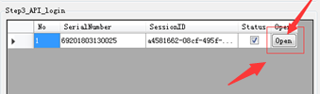 this is the common operation button, just click Open then we could use the normal operations.

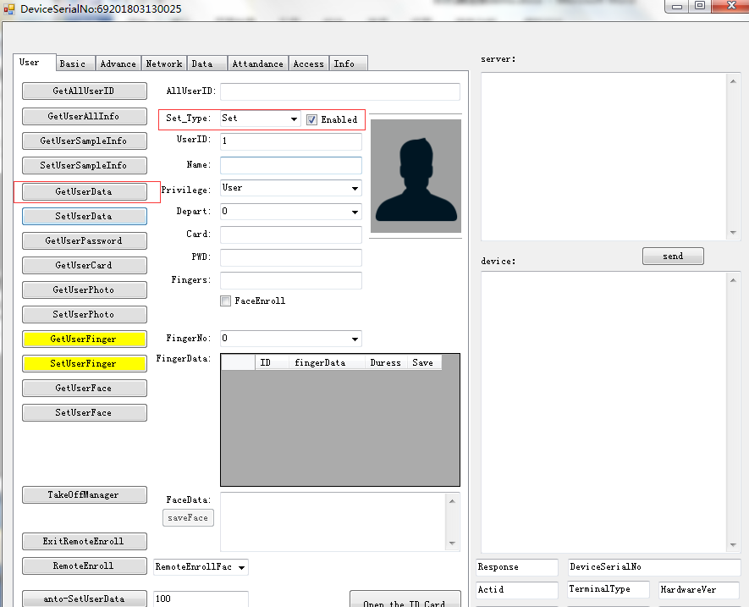

The operation is same as the interface from API document. There’re some interface that is not common use, so it might not be supported yet.

4. Time Attendance Device MENU Setting:

For different Device, the Setting menu might have a little bit different. Following is some common models.

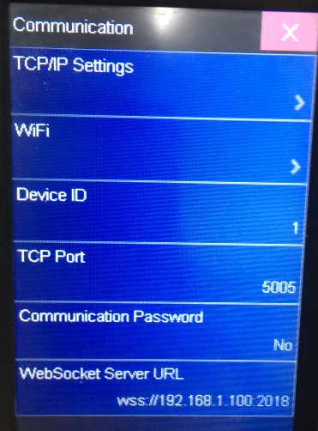

Face Device (M70) MENU – Setting – Communication – WebSocket Server URL

NOTE: for the Fingerprint Devices, they are using a higher version SSL encryption, need to run on the computer above WIN8.

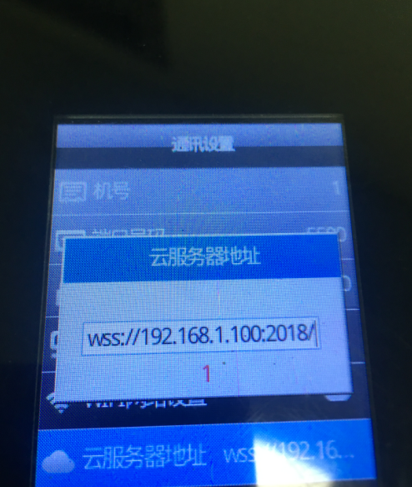

4900 (415)MENU:

MENU – Setting –Comm. Cloud Server Address